Vansh Thakral
500125288
Batch-1

Exercise 7- Install Minikube on Linux (Ubuntu /MacOS/Windows)

Install Minikube on macOS

brew install minikube

brew install kubectl

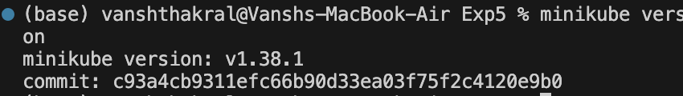

Start:

minikube start

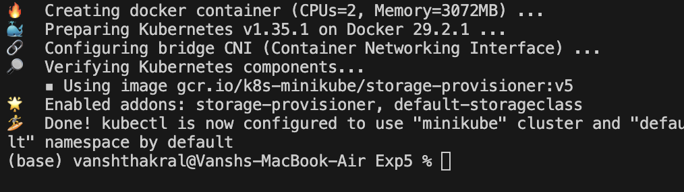

Verify Kubernetes Cluster

kubectl get nodes

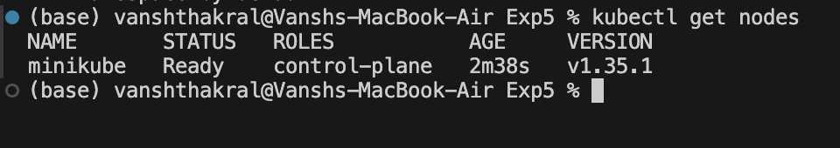

Expected output:

NAME STATUS ROLES AGE VERSION

minikube Ready control-plane xx v1.xx

Useful Minikube Commands (Lab Ready)
Command | Purpose
minikube dashboard | Open K8s UI
minikube stop | Stop cluster
minikube delete | Delete cluster
minikube ssh | Access node
kubectl get pods -A | View all pods

